

Session 4: Building a conversation

IBM Watson Assistant

**Lab Instructions**

Laurent Vincent

**Content**

Let’s get started 3

1. Overview 3

2. Objectives 3

3. Prerequisites 3

4. Scenario 3

5. What to expect when you are done 4

Create an Assistant in IBM Cloud 5

6. Create your Watson Assistant Service 5

7. Create a your first Skill 7

Intents 9

8. Create your first intent 9

9. Import intents 11

10. Test your Intents 12

11. Content Catalog 17

Entities 18

12. Create your first entity 18

13. Import entities 20

14. Test your entities 20

15. Contextual entities 22

16. Entity pattern 26

17. Test your pattern 26

18. Enable system entities 27

19. Test System Entities 28

Conversation Dialog 29

20. Create your first Dialog 29

21. Create your first nodes 34

22. Test your conversation 36

Enrich your data by using context variables 38

Create your first Assistant 40

# Let’s get started

### Overview

The [IBM Watson Developer Cloud](http://www.ibm.com/smarterplanet/us/en/ibmwatson/developercloud/) (WDC) offers a variety of services for developing cognitive applications. Each Watson service provides a Representational State Transfer (REST) Application Programming Interface (API) for interacting with the service. Some services, such as the Speech to Text service, provide additional interfaces.

The [Watson Assistant](http://www.ibm.com/watson/developercloud/conversation.html) service combines several cognitive techniques to help you build and train a bot - defining intents and entities and crafting dialog to simulate conversation. The system can then be further refined with supplementary technologies to make the system more human-like or to give it a higher chance of returning the right answer. Watson Conversation allows you to deploy a range of bots via many channels, from simple, narrowly focused bots to much more sophisticated, full-blown virtual agents across mobile devices, messaging platforms like Slack, or even through a physical robot.

The **illustrating screenshots** provided in this lab guide could be slightly different from what you see in the Watson Assistant service interface that you are using. If there are colour or wording differences, it is because there have been updates to the service since the lab guide was created.

### Objectives

In this lab, you will:

* Learn how to use the IBM Cloud (Bluemix) web user interface to create and manage Watson services
* Learn how to train your chat bot to answer some asked questions

### Prerequisites

Before you start the exercises in this guide, you will need to complete the following prerequisite tasks:

* Session 1 – Getting Started
* The instructor provided you the link to get labs content. You may download each file individually.

### Scenario

**Use case**: A Hotel Concierge Virtual assistant that is accessed from the guest room and the hotel lobby.

**End-users**: Hotel customers

### What to expect when you are done

At the end of session, you should have a simple dialog using

23 intents,

11 entities.

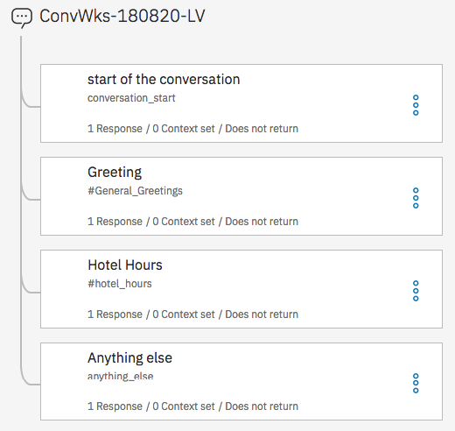

# Create an Assistant in IBM Cloud

### Create your Watson Assistant Service

IBM Cloud offers services, or cloud extensions, that provide additional functionality that is ready to use by your application’s running code.

You have two options for working with applications and services in IBM Cloud. You can use the IBM Cloud web user interface or the Cloud Foundry command-line interface. Today, you are using IBM Cloud user interfaces.

1. In a web browser, navigate to the following URL:

|  |  |
| --- | --- |
| **Location** | **URL** |
| worldwide | <https://console.bluemix.net/> |

1. Log in with your IBM Cloud credentials. This should be your IBM ID.
2. You should start on your dashboard that contains a list of all your applications and services. On the top left click **Catalog** to display the list of available services
3. Enter *Watson Assistant* as Filter

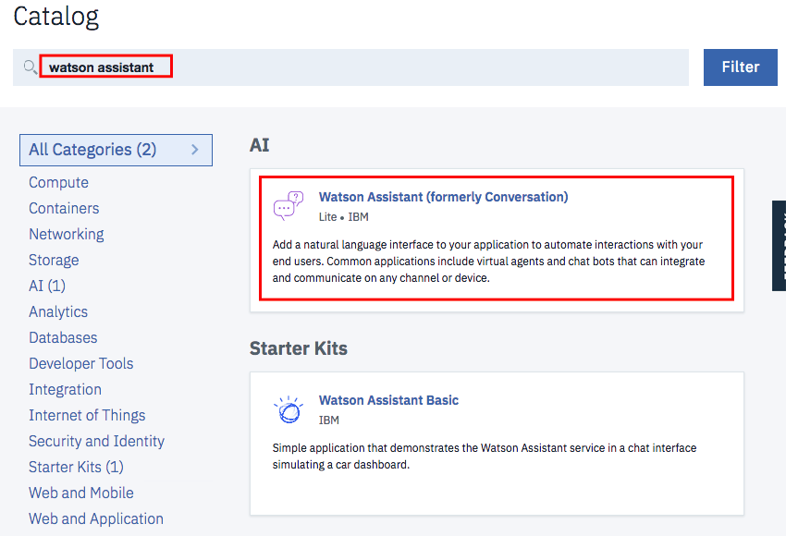

1. Click on the **Watson Assistant** service tile.
2. Review the details for this service. At the top, there will be a description of the service. At the bottom, you can review the pricing plans. For this service, notice that the first 10 000 API calls per month are free. Enjoy your demo!
3. At the top, you can enter information for your new service. In the middle, you can click on a pricing plan to select it. Fill out the fields as follows, then click **Create** at the bottom.

|  |  |
| --- | --- |
| **Field** | **Value** |
| Service name | *Conversation-****XXXXXX****-****LV*** |
| Region / location | *US South / Dallas* |
| space | dev |
| Selected Plan | *Lite* |

Where **XXXXXX** must be replaced with the date of the creation with the format yymmdd and **LV** must be replaced with your initials.

IBM Cloud has created a new service instance. In order to use this specific instance in your application, you will need to obtain the credentials. There are display in the manage tab.

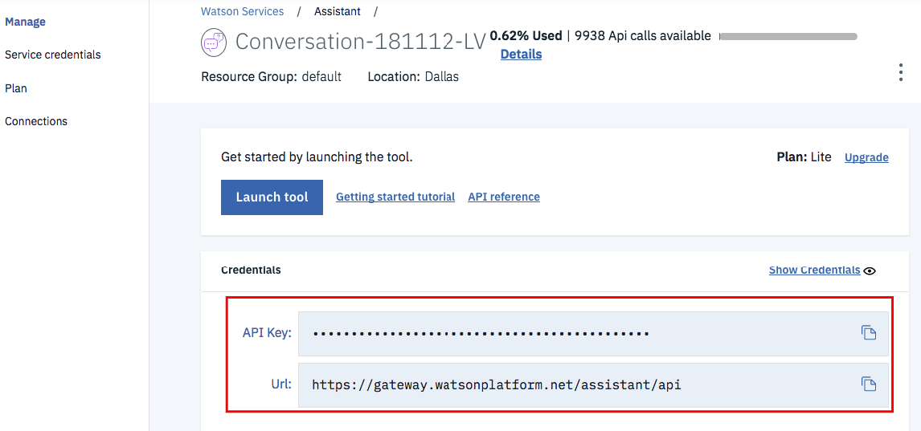

You should see the API Key and Url for your service. Later in this exercise, you will enter these values into a JSON configuration file for your Node.js and Node-Red application. Feel free to copy them to your clipboard, to a text file, or just return to this section of the IBM Cloud web interface when the credentials are needed.

### Create a your first Skill

To use the new conversation, you will need to train it with the intents, entities, and/or dialog nodes relevant to your application’s use case. You will create these items in a Skill. A Skill is a container for the artefacts that define a piece of the behaviour of your service instance.

1. On the left side of the page, click the **Launch tool** button.



Your first step in the Watson Assistant tool is to create a skill.

1. From the home page of the Watson Assistant tool, at the bottom, click **Create a Skill** tab

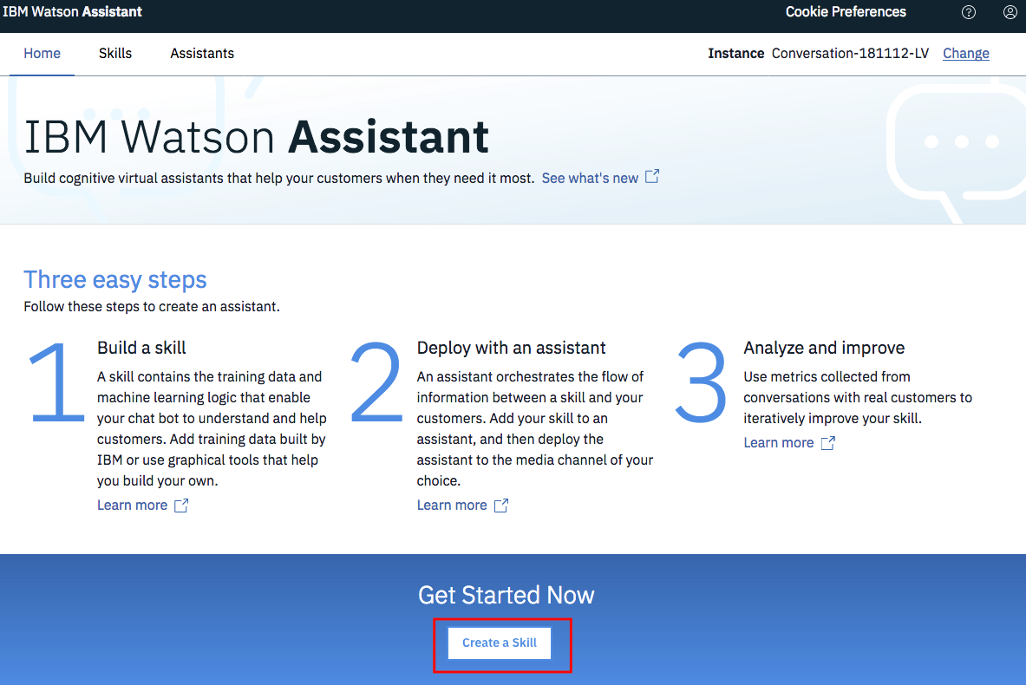

1. Skill enables you to maintain separate intents, user examples, entities, and dialogs for each application. Click **Create new**.

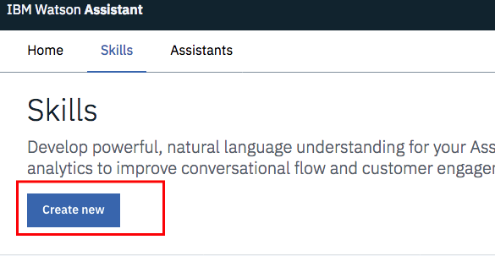

1. In the *Create a skill* wizard, enter the following values and click **Create**.

|  |  |
| --- | --- |
| **Field** | **Value** |
| Name | *ConvWks-****XXXXXX****-****LV*** |
| Description | *For demos only* |
| Language | *English (U.S.)* |

Where **XXXXXX** must be replaced with the date of the creation with the format yymmdd and **LV** must be replaced with your initials.

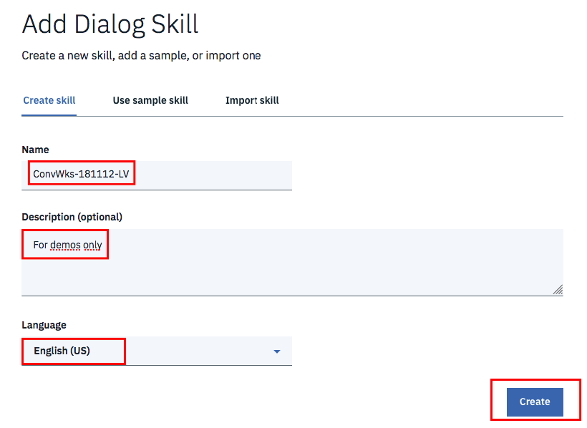

Once the workspace has been created, your workspace should be displayed to start to create your first intent.

# Intents

### Create your first intent

In order to use the new conversation, you will need to train it with the intents, entities, and/or dialog nodes relevant to your application’s use case. An intent is the purpose or goal of a user’s input.

1. First, you will need to define some *intents* to help control the flow of your dialog. An [*intent*](https://console.bluemix.net/docs/services/conversation/intents.html#defining-intents) is the purpose or goal of a user’s input. In other words, Watson will use natural language processing to recognize the intent of the user’s question / statement to help it select the corresponding dialog branch for your automated conversation. If not already there, click the **Intents** tab at the top of your workspace.
2. On the *Intents* tab, click **Add intent** in the dialog window.

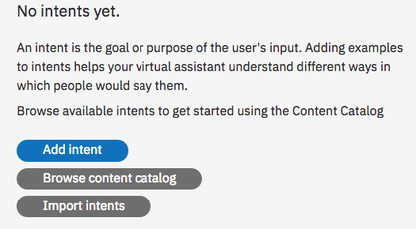

1. Enter *hotel_locations* as Intent name then click **Create intent**

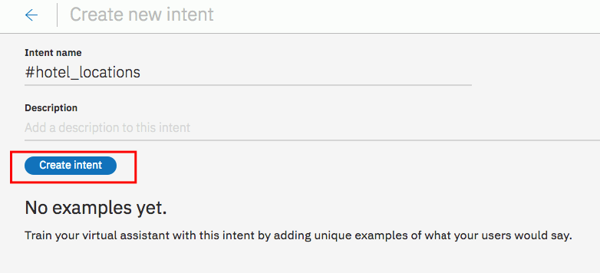

1. Enter the examples as defined below in the **Add user examples** field and click **Add example** button after each of them. The *user examples* are phrases that will help Watson recognize the new *intent*.

|  |  |
| --- | --- |
| **Field** | **Value** |
| Intent name | *hotel_locations* |
| User example | *Is the pool outside?*  *Where is the gym?*  *Do you have a sauna?* |

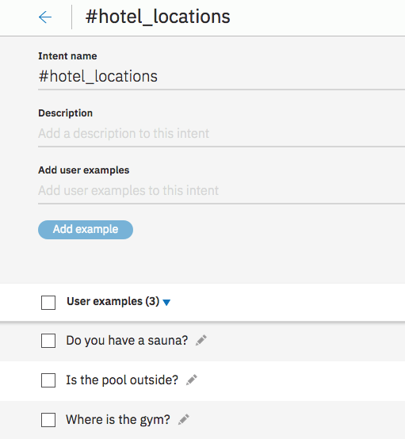

1. When finished, click on the arrow Icon (top left side of the window) to go back to list of existing intents

At this point, you have defined one *intent* for the application along with the example utterances that will help train Watson to recognize and control the conversation flow.

### Import intents

Intents can be imported into the Conversation tool using a Comma Separated Values (CSV ) file saved with UTF-8 encoding.

In order to import a file successfully, it must include only two columns: one for user examples and one for intents.

**Note**: This step has already been done for you. This section is for future reference only. Please proceed to the next numbered lab step to proceed with the lab guide exercises.

* Copy the end-user examples into a single column.
* Label each end-user example with its assigned intent in the column beside it.
* Do not insert any column headings for the intent import file.
* Use a text editor to make sure that your file is UTF-8 and saved as a .csv file. We suggest Numbers for Mac and Notepad++ for Windows.

**Note**: This step is important because many text processing software programs add spaces and other foreign characters to text when it is copied and pasted into a new source file that are often hidden. When the files are uploaded into the Conversation tooling, these spaces can be converted to symbols that will negatively affect learning by adding text that the user did not, and in many cases, will not type or speak to Watson.

1. Click **Import**

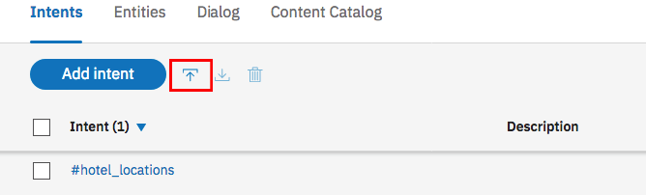

1. Drag *WCS_Lab_Intents Before Session 4.csv* into the **Choose a file** box or click **Choose a file** to browse your computer.

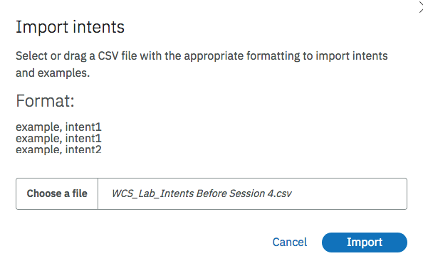

1. Click **Import**

**Note**: Notice that the Conversation tooling did not import any questions that were exact duplicates of questions that you manually entered. Duplicates are not case sensitive. For example, “Do you have a sauna*?”* is the same as “do you have a sauna”. It did import questions that had semantic differences, such as the absence of punctuation, extra spaces between words, or misspelled words.

So all existing utterances of hotel_locations were ignored:

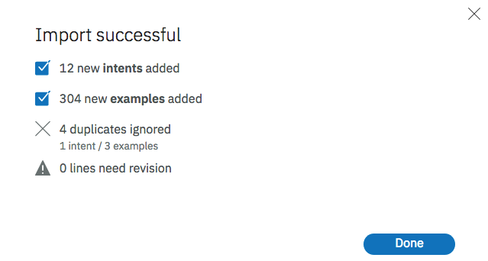

1. Click **Done**

Your conversation should have 12 intents, with 307 utterances

### Test your Intents

**Try it** panel is used for testing in the lab guide.

When WA is training on recently added data. You must wait for the message highlighted with purple to clear before you can test newly added intents, utterances, entities. Watson will respond, but you will get unpredictable results until the training is complete.

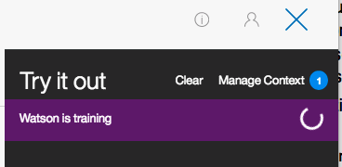_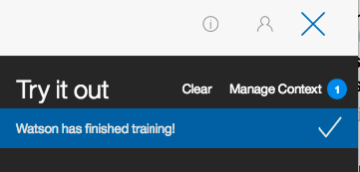

1. Open the **try it** panel by clicking on the following icon (upper right):

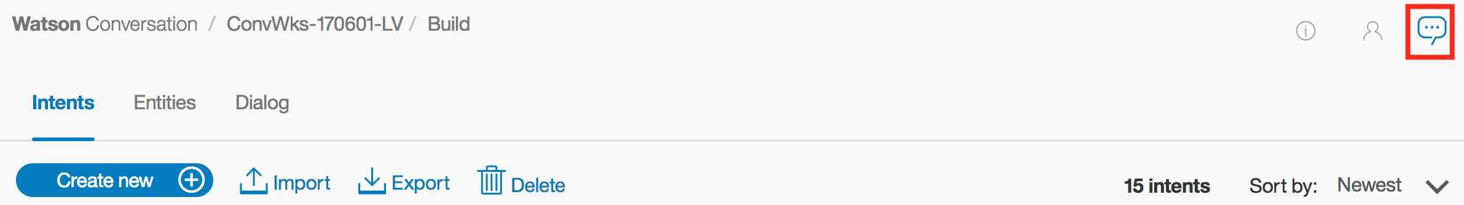

You cannot perform the **Try it out** activities in this section until Watson has finished training on your recent changes. When Watson is finished, the purple box with the text, “Watson is training” will no longer appear in your "Try it out" panel. You may also notice a message stating that, "Watson has finished training!".

1. Type *how do I get in the gym?*

**Note:** Notice that Watson assigns this question to the intent *#hotel_locations*. The *#hotel_locations*intent is meant for questions that refer to finding directions for locations within the hotel. In this case, the user wants to know how to get in the gym, not how to get to the gym.

Let’s change the intent for the user example.

1. Click the arrow next to *#hotel_locations*

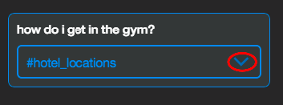

1. Type *hotel_info*

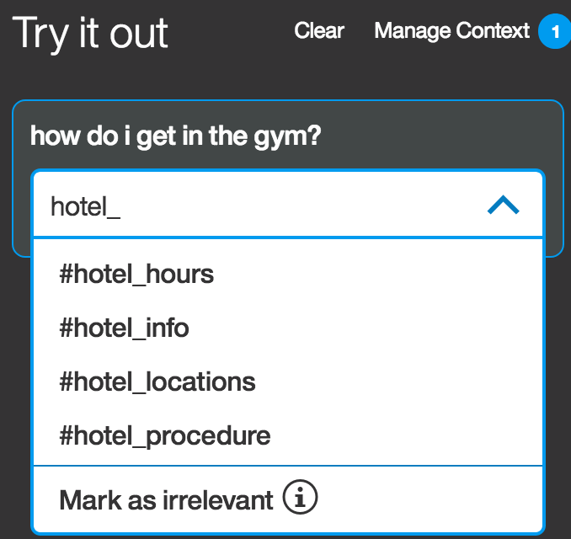

1. Select the intent *#hotel_info* that appears in the drop-down box

Your try it out panel will show a message similar to “Watson is training”

**Note**: If you go to your Intents panel, and open the *#hotel_info* intent, you will now see that your input has been added to this section.

1. Type *I want to eat at an Italian restaurant?*

**Note:** Notice that Watson assigns this question the intent *#Local_recommend*. This intent is meant for questions that refer to finding recommendation for sightseeing or restaurant. In this case, the user wants to eat something.

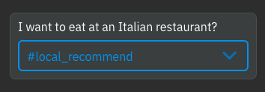

Let’s change the intent for the user example, this time by using the search capability of the engine.

1. Close the **Try it out** Panel
2. ON the intent tab click on the search icon

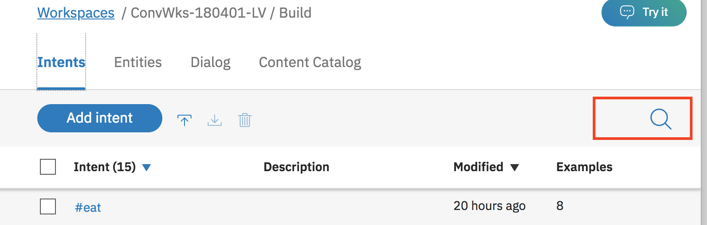

1. Enter *eat* in the search field (retry this search if indexing is needed)

The solution returns all intents including the ‘eat’ word.

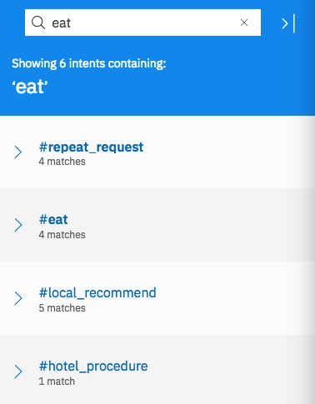

1. As you are looking for a user example which belongs to #local_recommend, expand it.

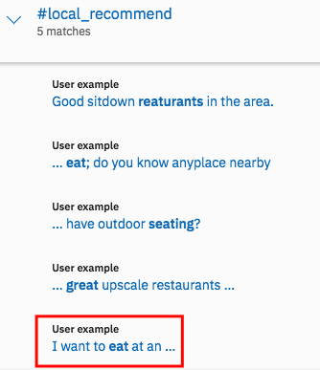

1. The last one looks like the one we used during the test, click on it

Watson open a right page and highlight the right user example.

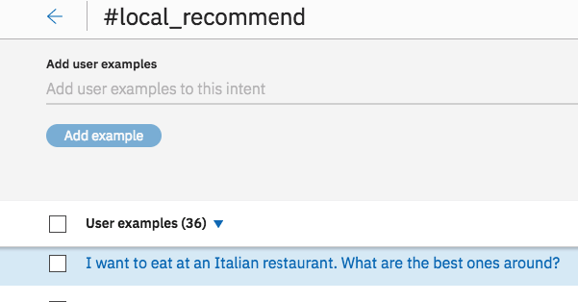

1. Select it, click on **Move**

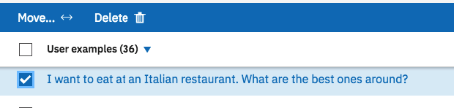

1. Enter *eat* as intent

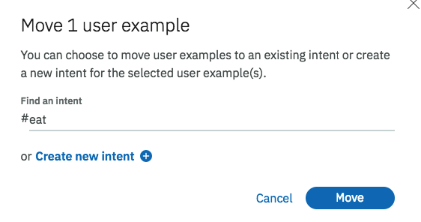

1. Click on **Move**

**Note**: Now, your user example is move on the right intent and if you will do a new test the system returns the right intent.

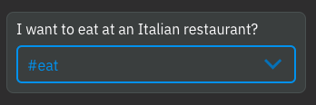

You have seen two options to improve the Watson classification

Add a new user example in an existing intent

Move an existing user example to the right intent.

You are going to review several other options during this workshop.

### Content Catalog

***Content Catalogs*** provide an easy way to add common intents to your Watson Assistant service workspace.

You are going to add general conversation topics intents.

1. On the **Content Catalog** tab, click Add to workspace to add General category intents.

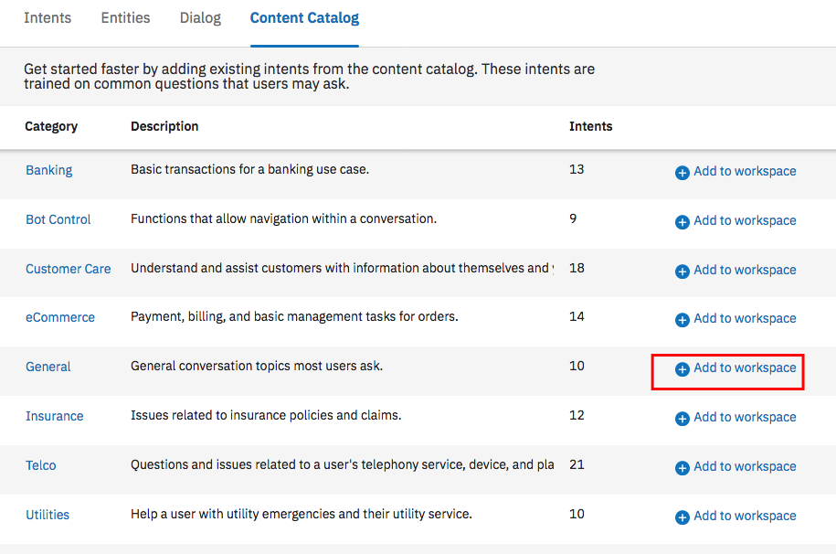

1. Go back to **Intents** tab, we will find new intents prefix by #general_

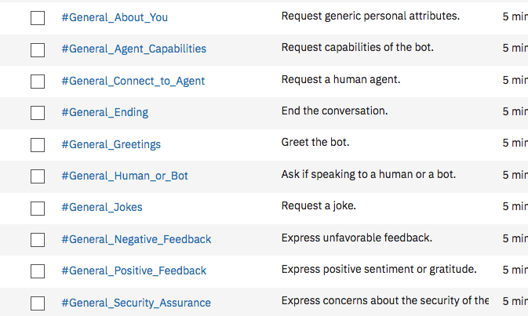

# Entities

### Create your first entity

To use the new conversation, you will need to train it with the intents, entities, and/or dialog nodes relevant to your application’s use case. An entity is the portion of the user’s input that you can use to provide a different response or action to an intent.

**Note:** you will need to create some *entities*. An [*entity*](https://www.ibm.com/watson/developercloud/doc/conversation/entities.html) is the portion of the user’s input that you can use to provide a different response or action to an intent. These entities can be used to help clarify a user’s questions/phrases. You should only create *entities* for things that matter and might alter the way a bot responds to an *intent*.

1. If not already there, click the **Entities** tab at the top of your workspace.
2. Click **Add entity**.

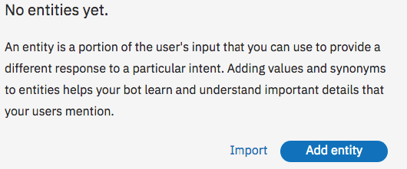

1. As you did for intent create your first entity with the following information

In these labs, several intents will indicate that the user are looking for a restaurant. So, you will need to create a new *entity* representing restaurant categories. You will then provide *values* (and possibly synonyms) for the various types. (Enter multiple *examples* by pressing “Enter” or clicking the **plus sign** at the end of the line.)

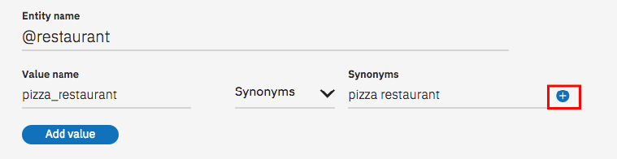

|  |  |  |
| --- | --- | --- |
| **Field** | **Value** | **Synonym** |
| Entity name | *restaurant* | << N/A >> |
| Value | *pizza_restaurant* | *pizza restaurant, pizza, pizza pie, pizzeria* |
|  | *chinese_restaurant* | *chinese restaurant, spring roll, noodles* |
|  | *french_restaurant* | *french restaurant, brasserie, frog legs, macaron* |

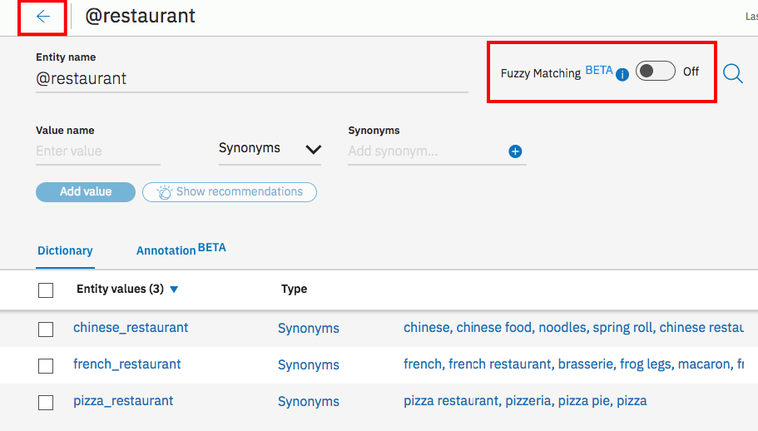

1. Enable the **Fuzzy Matching** option
2. When finished, click on the arrow icon

### Import entities

Entities like intents can be imported into the Conversation tool using a Comma Separated Values (CSV ) file saved with UTF-8 encoding.

In order to import a file successfully, it must include a minimum of two columns: one for entity names and one for entity values which can be followed by the synonyms.

1. Click **Import**
2. Drag *WCS_Lab_Entities.csv* into the **Choose a file** box or click **Choose a file** to browse your computer.

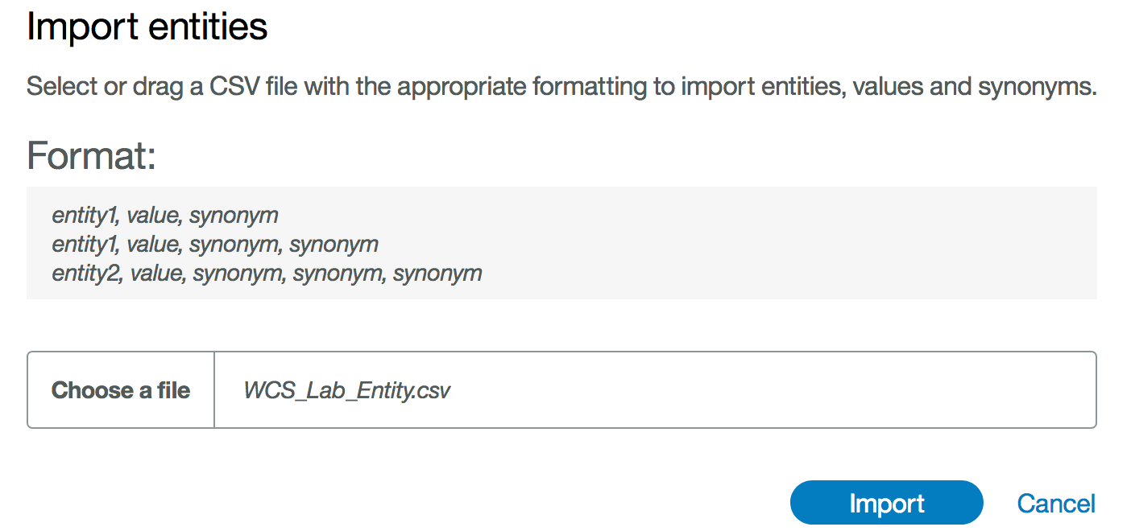

1. Click **Import**

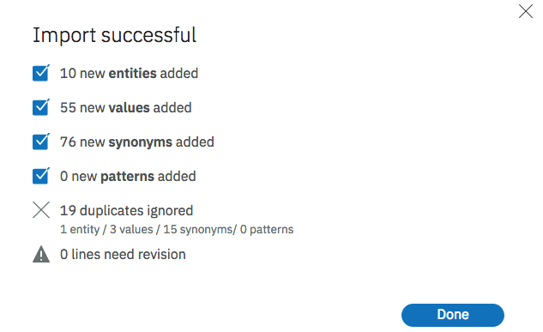

**Note**: Notice that the Conversation tooling did not import any questions that were exact duplicates of questions that you manually entered. So the existing restaurant entity name were ignored.

### Test your entities

1. Open the **try it out** panel, wait until Watson is done training.
2. Type *where is the bike?*

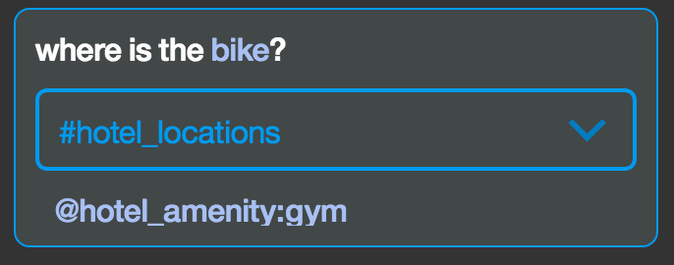

**Note:** Notice that Watson has identified the term bike with the correct intent, entity, and entity value (*@entity_name:entity_value)*.

Type *where are the bikes?*

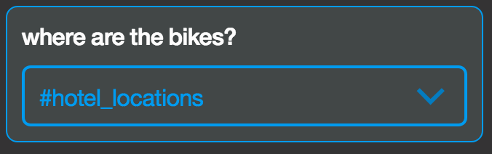

**Note:** Notice that Watson does not identify bikes the same as it identified bike. This is because entity matching is brute-force rules-based string matching without fuzzy matching.

Let’s turn on fuzzy matching to see how it improves entity recognition.

1. Open the *Hotel_amenity* entity and turn on **Fuzzy Matching**.

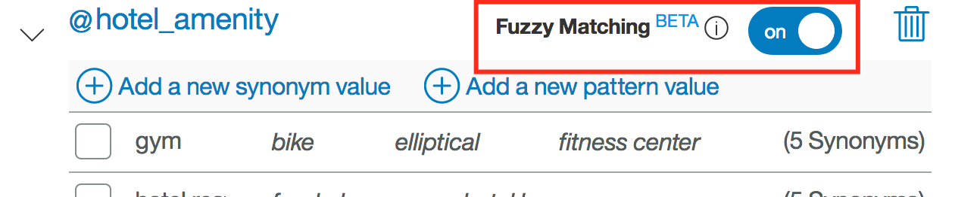

1. When Watson is done training, type *where are the bikes?*

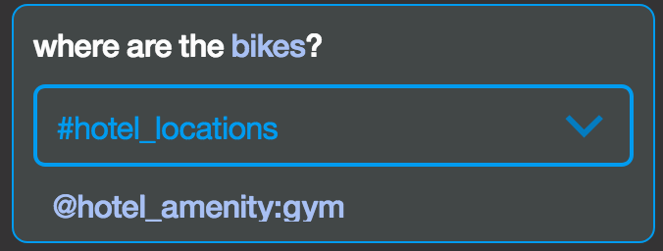

**Note**: notice that the correct *@entity name:entity value* pair is now recognized for *bikes*.

1. Enables the **Fuzzy Matching** for the entities *@pizza-toppings* and *@pizza_notoppings*.

### Contextual entities

When you define specific values for an entity, the service finds entity mentions only when a term in the user input exactly matches (or closely matches if fuzzy matching is enabled) a value or synonym defined. When you define a contextual entity, a model is trained on both the entity *value* and the *context* in which the entity is used in sentences that you annotate. This new contextual entity model enables the service to calculate a confidence score that identifies how likely a word or phrase is to be an instance of an entity, based on how it is used in the user input

1. Open **Try it out** panel.
2. Enter *I want a pizza without anchovy and more olives* at the bottom of the chat window.

The bot understands the #order_pizza intend and the entities @pizza_toppings and @pizza_notoppings but it can’t determine what the user want and don’t want!

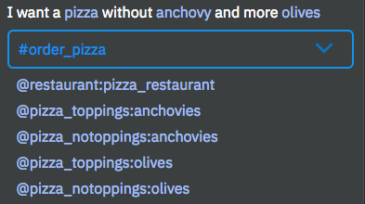

Watson needs to know the context.

We are going to annotate the user’s example to identify where the entities are used.

1. Go to **intents** tab and select *#Order_pizza*
2. In the 4th example, highlight the group *red peppers* the enter *@pizza_toppings*

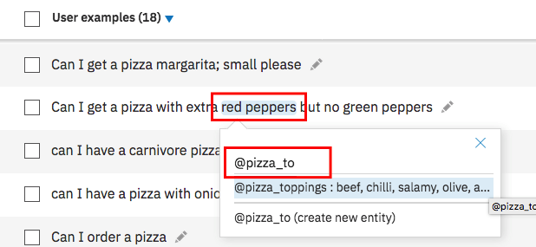

We identify the toppings requested by the user.

1. Annotate the other entities like below.

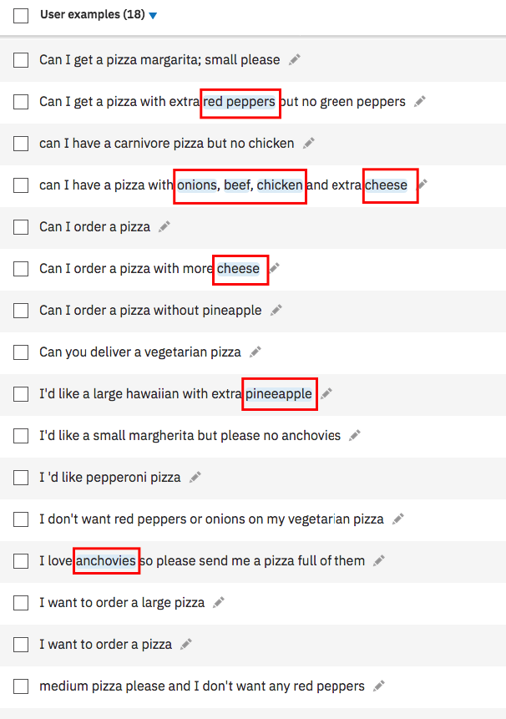

Now, we are going to identify the toppings not requested by the user.

1. Annotate the intent using @pizza_notoppings entities like below.

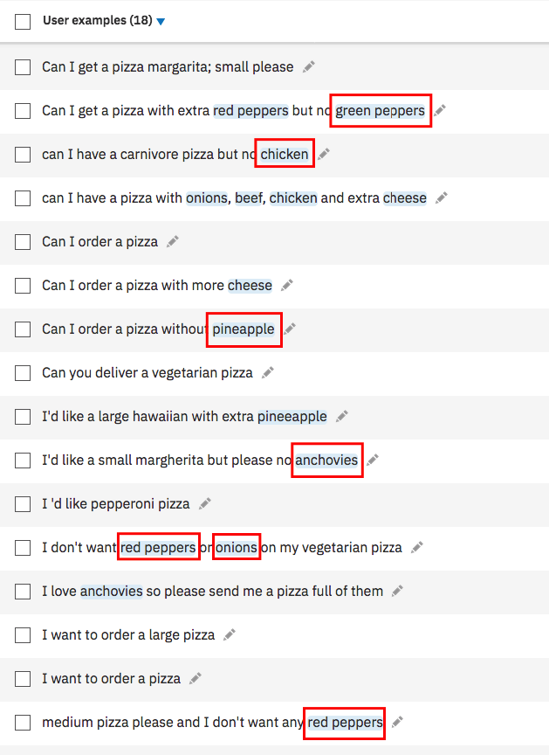

1. Open **Try it out** panel.
2. Enter *I want a pizza with more olives and without anchovy*

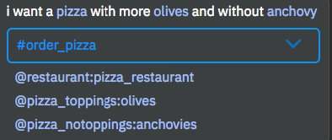

So, pretty cool!

If we open the entity *@pizza_notoppings*, and the **Annotation** tab, we retrieve the annotated examples.

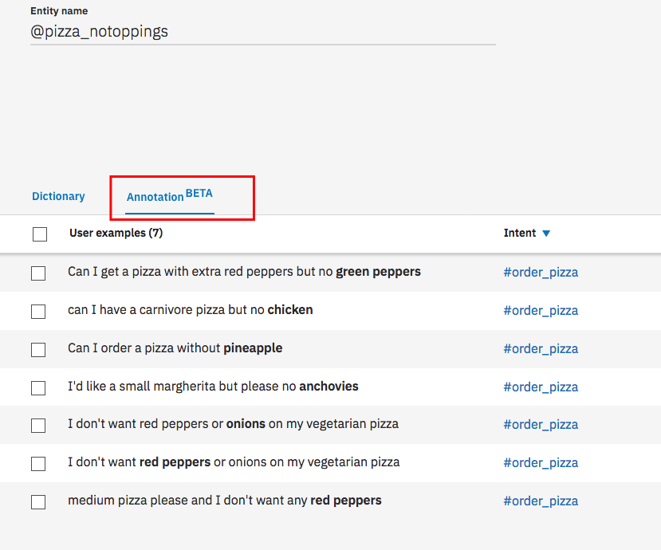

### Entity pattern

1. Click **Add entity**.
2. Enter  
   as entity name : *@pattern*
3. Click **Create entity**
4. Enter  
   as value : *email address*  
   as pattern: *\b[A-Za-z0-9._%+-]+@[A-Za-z0-9.-]+\.[A-Za-z]{2,}\b*

as type select Patterns

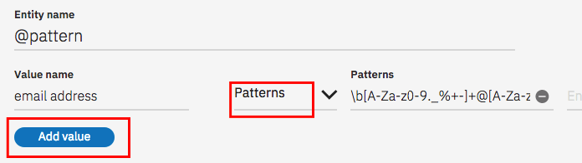

1. When finished, click **Add value**, then click on arrow icon

That the way to extract an e mail address from the user input

### Test your pattern

1. Open the **try it out** panel, wait until Watson is done training.
2. Type: *it is johndoes@gmail.com*

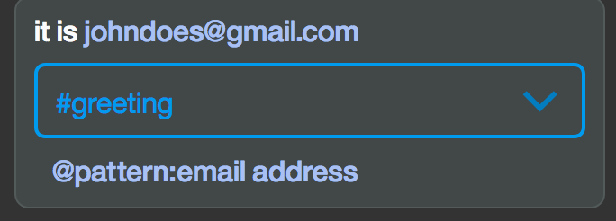

Watson identify johndoes@gmail.com as an entity email address.

### Enable system entities

1. You will need to enable system entity. These entities can be used to help clarify a user’s questions/phrases. If not already there, click the **Entities** and **System entities** tabs at the top of your workspace.

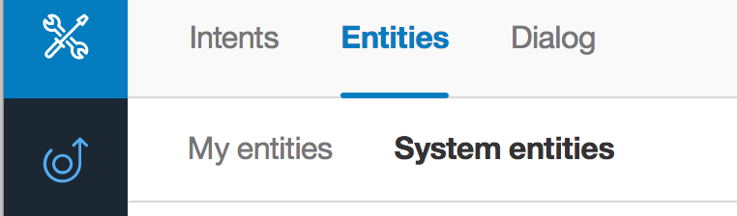

you will get

* **@sys-number:** detects numbers that are written using either numerals or words. In either case, a numeric value is returned.
* **@sys-currency:** detects monetary currency values that are expressed in an utterance with a currency symbol or currency-specific terms. A numeric value is returned.
* **@sys-percentage:** detects percentages that are expressed in an utterance with the percent symbol or written out using the word percent. In either case, a numeric value is returned.
* **@sys-date, @sys-time and $timezone:** Mentions of a date range such as the weekend, next week, or from Monday to Friday are extracted as a pair of @sys-date entity mentions that show the start and end of the range
* **@sys-location :** extracts place names (country, state/province, city, town, etc.) **BETA, English-only**
* **@sys-person :** extracts names from the user's input. **BETA, English-only**

1. Switch on all system entities.

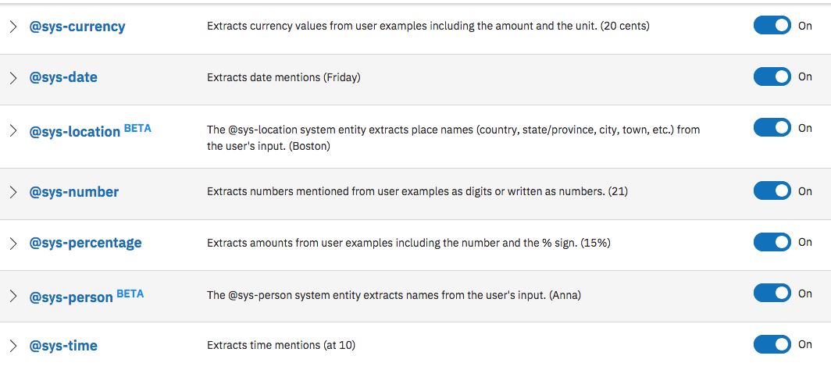

### Test System Entities

1. Open the **try it out** panel, wait until Watson is done training.
2. Type *Is the gym open at 6 am tomorrow?*

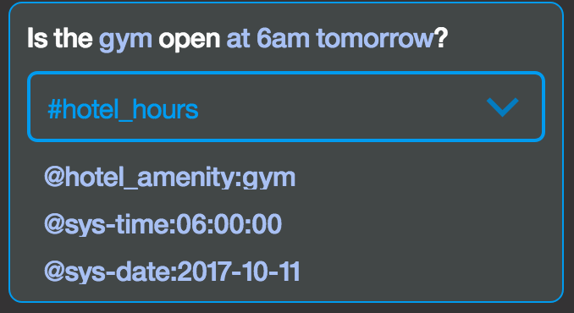

**Note**: notice that the time and date are recognized

**6am** has been captured **06:00:00** which the standard time format

**tomorrow** has been captured **2017-10-11** (yyyy-mm-dd) which is the format the current date is Oct the 10th.

1. Type *Did the restaurant charge a 15% tip for a 20$ bill today?*

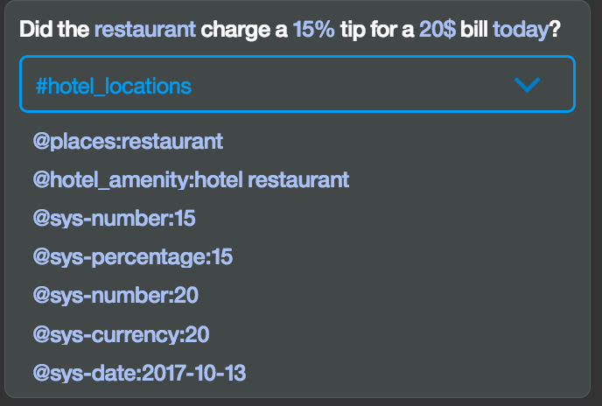

**Note**: notice that the percentage, currency, number and date are recognized. You can use these system entities in your dialog node calculations the same way you would use your custom defined entities.

# Conversation Dialog

### Create your first Dialog

To use the new conversation, you will need to train it with the intents, entities, and/or dialog nodes relevant to your application’s use case. A dialog uses the intent and entity that have been identified, plus context from the application, to interact with the user and provide a response.

A dialog chat flow is made up of nodes. **Nodes** define the steps in the conversation or chat flow. Dialog nodes are chained together in a tree structure, and each node can be defined by two parts: a condition and a response

A **condition** is the portion of the dialog node that determines whether the node is used in the conversation. Conditions can be defined using intents, entities, context variables, and special conditions. The Spring Expression (SpEL) language is used to write valid expressions for conditions.

A **response** is activated if the node’s condition matches the user input. A response is returned to the end-user and can be either simple text or a more advanced process (such as walking the user through the process of changing their password).

Each node has a node menu. This guide will go through most of the actions that can be completed from the node menu, but be sure to note that **delete** will remove the node and all of its child nodes.

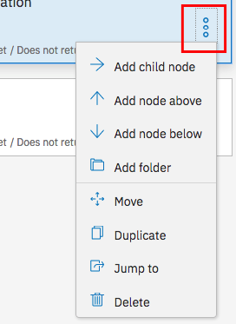

1. Click on **Dialog** tab
2. Click on **Create**

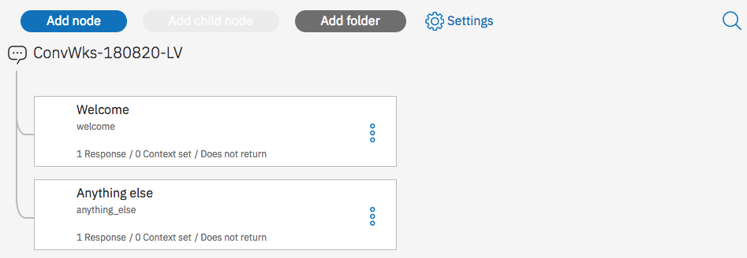

You can notice that Watson has created 2 nodes a “*Welcome*” and “*anything_else*” nodes.

**Note:**

* The **Welcome** node is automatically added to your dialog chat flow. Welcome is a special condition in Conversation that only evaluated as true during the first dialog turn when the application does not contain any user input. If the initial request from the application contains user input, it will not be triggered. Typically, welcome is used when you always want to display a message or a greeting at the beginning of the conversation.
* The **Anything else** node is automatically added to you dialog chat flow. The Anything else node is set to always evaluate to true. Its purpose is to always provide a response to the user if the user’s input does not evaluate to true for any other parent node in the tree.

**Click on the Anything else** node to review the pre-trained responses. You may edit these if you wish.

* The panel that appears on the **right side of the screen** is the editor panel for the node. When you create a new node or when you click on a node to make edits, this panel will appear for the node that you click on. This is where all editing is done for the node. The image below explains the elements of the node editor.

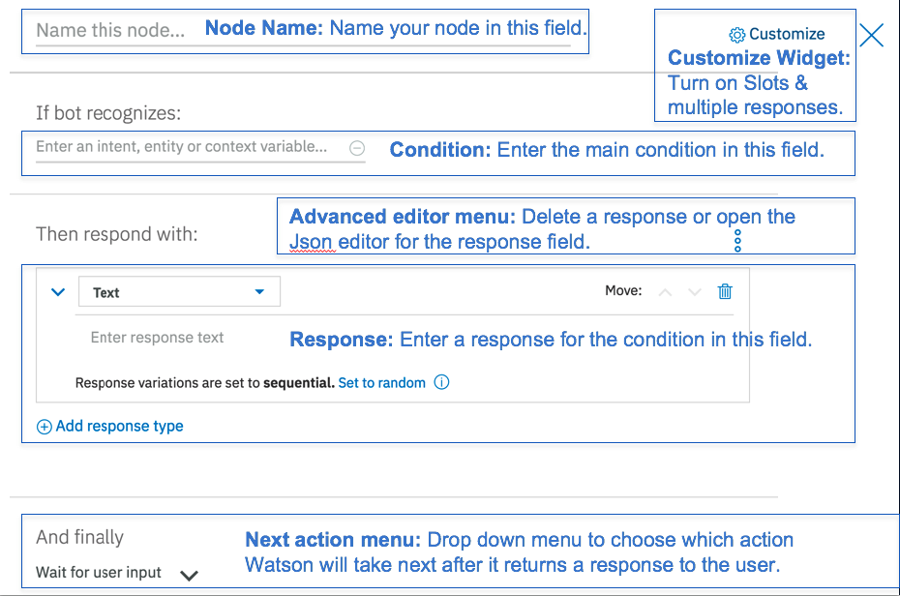

1. Select **Welcome** node to edit it and fill it as below

|  |  |
| --- | --- |
| **Field** | **Value** |
| Name of the node | *start of the conversation* |
| If bot recognizes | *conversation_start* |
| Watson responses | *Hi! I am Watson, nice to meet you* |

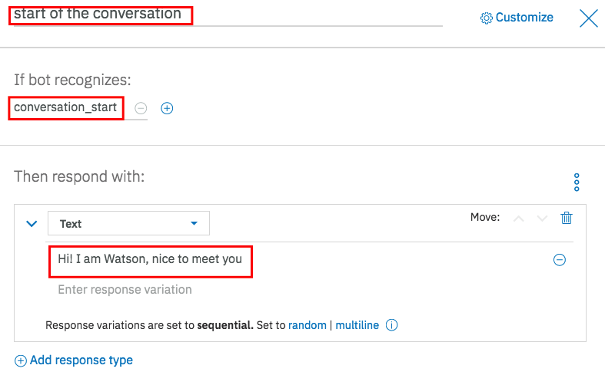

1. Select the **anything_else** node, 3 responses are pre-created.

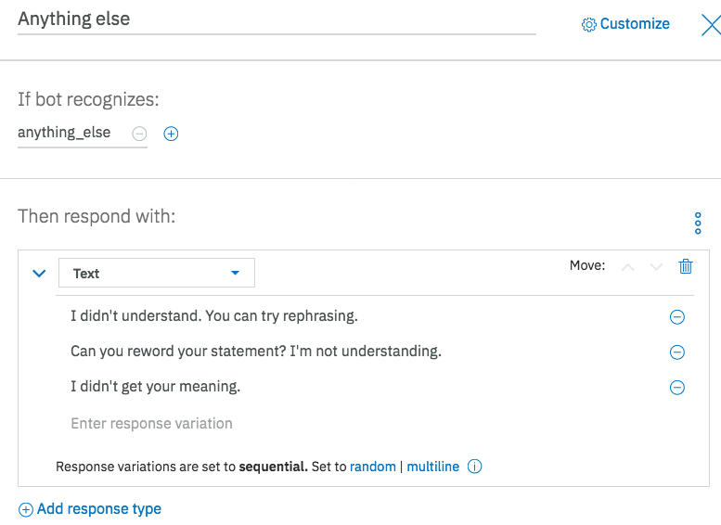

### Create your first nodes

You can create a dialog branch for each of the *intents* you identified as well as the start & end of the conversation. You should also greet the end user as appropriate. For the greeting, you can create a new dialog node to respond to a *greeting* intent. To do this you are going to leverage the intent *#General_Greetings* that you have imported in earlier steps.

**Note**: When you click on add node button at the top of the tab. The node will be added below the selected node. So best way to add correctly a node is to use the **node menu.**

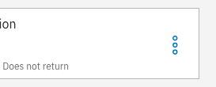

1. Select the **start of the conversation** node
2. Click **node menu**
3. Click **Add node below**

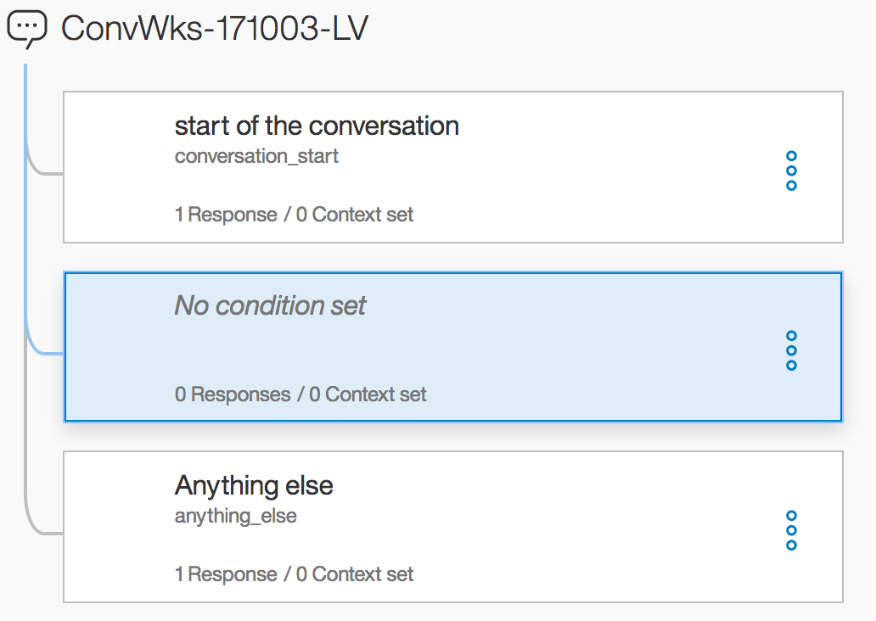

1. In this new node, enter the following values. By setting the condition to an *intent*, you are indicating that this node will be triggered by any input that matches the specified *intent*.

|  |  |
| --- | --- |
| **Field** | **Value** |
| Name of the node | *Greeting* |
| If bot recognizes | *#General_Greetings* |
| Watson responses | *Hi! What can I do for you?* |

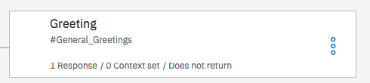

**Note**: The figure above indicates that there is only one condition that is evaluated, one response and zero variable context used.

You will create another dialog branch to respond to the *#hotel_hours* intent. Because there are multiple possibilities to manage this intent, this branch could be more complex. Right now, we will keep it simple

1. Add a node below the greeting node as below

|  |  |
| --- | --- |
| **Field** | **Value** |
| Name of the node | *Hotel Hours* |
| Triggered by | *#hotel_hours* |
| Watson responses | *The @hotel_amenity is open from 6am to 9pm* |

@hotel_amenity is the entity captured by Watson. The bot will return this information and demonstrate that it understood the request.

### Test your conversation

Now, you should have a dialog with four nodes.



it’s time to test it.

1. Open **Try it out** panel.

A test user interface will immediately launch and, based off the root node you just created, provide a greeting to the end user. (You may see a message that Watson is being trained.)

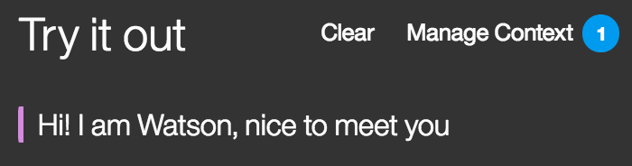

1. Enter *Hi*at the bottom of the chat window.

The bot understands the #General_greetings intend and send you back the right response.

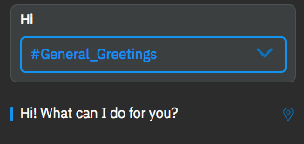

1. Enter *When is the* ***fitness center*** *open?*

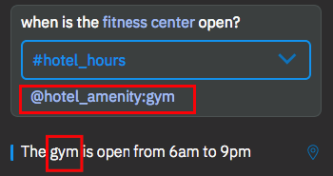

**Note**: Watson should return the response that is matched to #hotel_hours and @hotel_amenity:gym

1. Enter *When is the* ***store*** *open?*

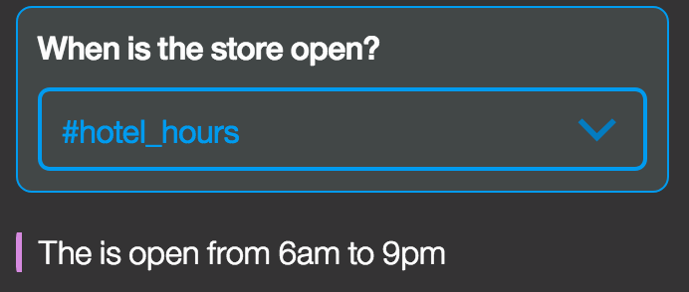

**Note**: Watson understood the intent #hotel_hours. But as *store* is not defined as value of any entities, the system returns the answer without @hotel_amenity value. During the next lab, we are going to understand how to improve the WA behaviour to manage such behaviour.

1. Enter *abcdefg*

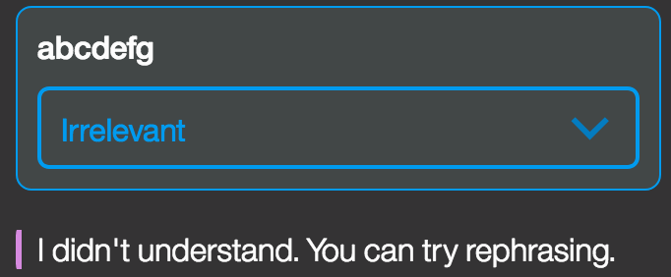

Watson cannot identify anything and executes the **anything_else** node.

# Enrich your data by using context variables

Watson Assistant allows you to store information. This is done using the ‘context’. For example, when asked where something is, you may wish to show a map. So, your dialog can store the location in the context, and your application can use it to show the location on a map. You can set variables in the context using the advanced response editor.

There are two methods to access a context variable:

* Shorthand: $variable_name
* Full Syntax: context.variable_name

1. To view the context variables that have been set for a conversation, open the **try it out** panel, and click on **Manage Context**

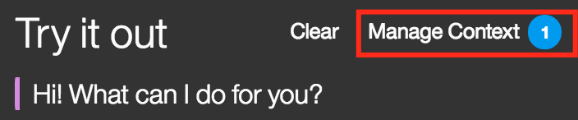

This will open the **Context variables** panel.

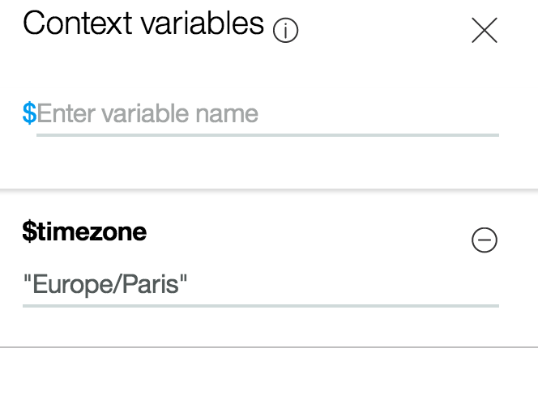

The number beside Manage Context tells you how many context variables are set;

By default, as you enable sys_date and sys_time system entities, Watson sets the user’s time zone in the $timezone context variable.

1. Close **Manage Context**
2. In the **try it out** panel, enter *now*

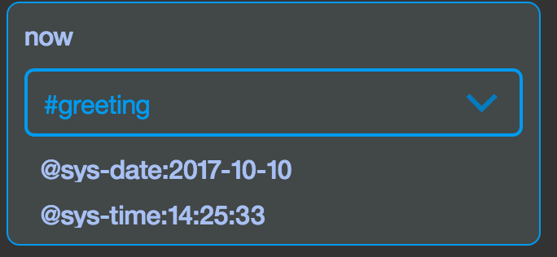

1. Go back to **manage context** panel and update *$timezone*
2. Replace *Europe/Paris* with *America/Los_Angeles*

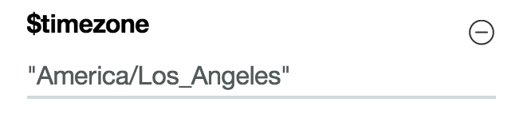

1. In the **try it out** panel, enter *now*

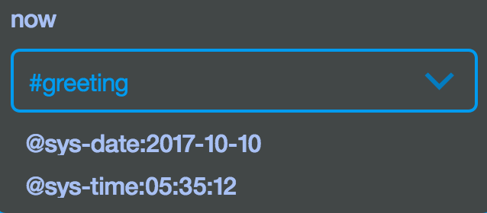

You can see that WA applied the new time zone.

1. To avoid any confusion in the time zone, reuse *Europe/Paris* as context variable value for $timezone or your time zone.

**Important Note:**

Save your workspace to your laptop (Click on Download as JSON on the workspace tile)

# Create your first Assistant

A Assistant is a virtual container to which you add your skills that enables it to interact with your customers in useful way.

There are two methods to access a context variable:

* Shorthand: $variable_name
* Full Syntax: context.variable_name

1. Select **Deploy** menu then click **Add to an assistant**

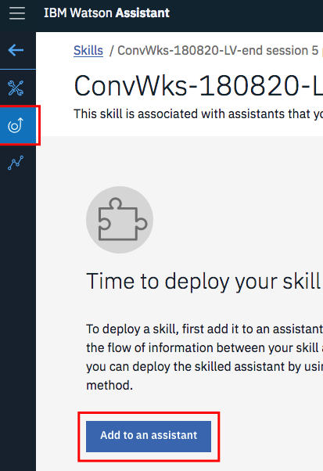

1. Click **Create New**
2. Fill assistant as below

|  |  |
| --- | --- |
| **Field** | **Value** |
| Name | *Concierge* |
| Description | *For concierge demo* |
| Enable preview link | Keep it selected |

1. Click **Create**
2. Click **Add Dialog Skill**

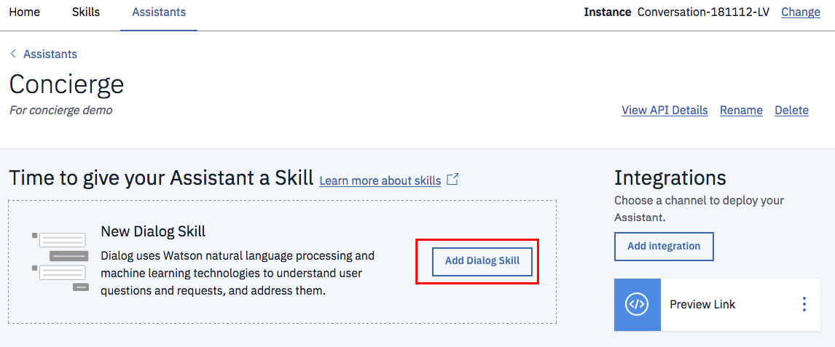

1. Select **Add existing skill** then select the skill you have previously created

Now you assistant to use.

1. You are going to review the sample UI to test your assistant. Click **Preview Link** tile.

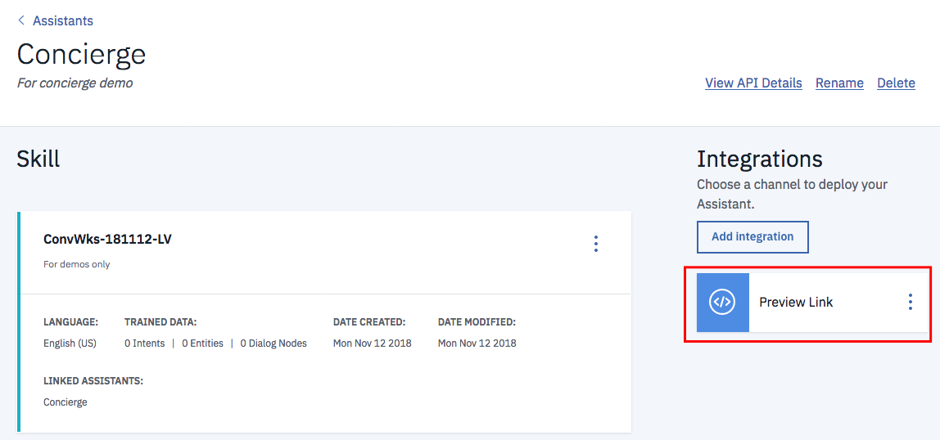

1. You can use the URL link to test your Assistant. Click on the hyper link

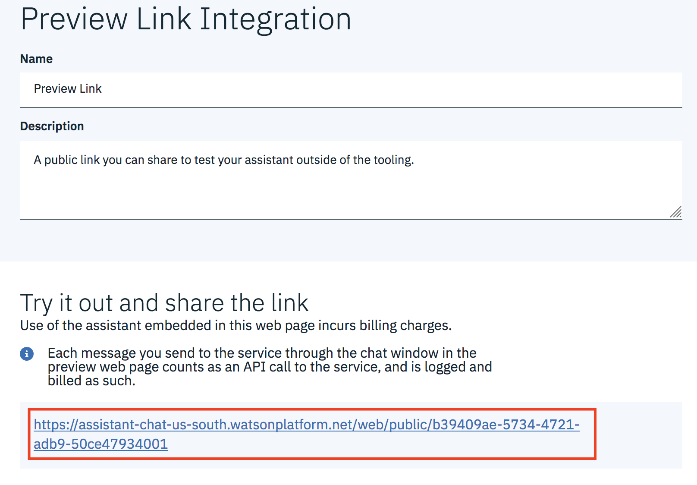

1. You can use the page to test your Assistant.

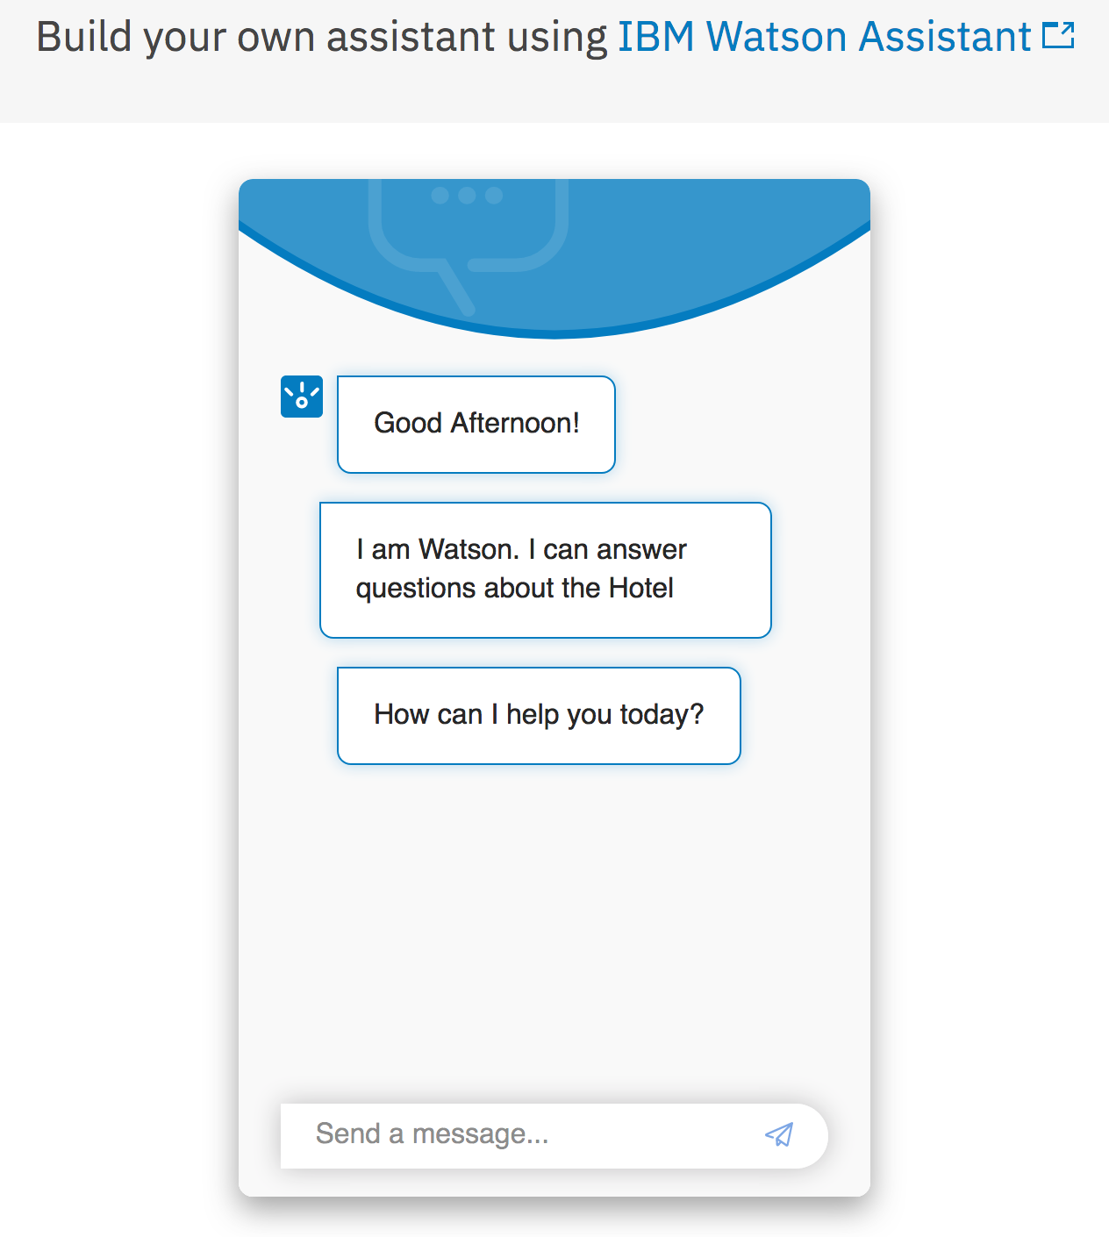

**END OF LAB**